* **SOLIDUS LABS**
* **PRODUCT SPECIFICATION**
* **Retail Client Onboarding**
* **For**
* **Rialto Markets**
* **CONFIDENTIAL**
* Version 1.0

INTRODUCTION

Investor Types

Retail Investor

Accredited Investor

Institutional Investor

Retail Investor Onboarding Workflow

Retail Investor Interface

Self Registration with Email

Email Verification and Password Setup

Applicant Information

Account Type

Personal Details

Documents Upload

Transfer Agent

Funding

Open Account With Rialto

Plaid Integration

Application Status

Updates and communication

Compliance Interface

Applications Overview

Application Queue

Application Details

AML/KYC Checks Integration

Single Customer View

ATS Integration

Bulk Onboarding

# **INTRODUCTION**

This product specification document is intended to be a living document that would serve as an authoritative source of information on Solidus Lab’s implementation of Retail Onboarding Solution for Rialto Markets. Internal to Solidus, this document will serve as functional specification and the basis for documentation of technical specifications by the engineering team. Externally, this document will be the basis of detailed product information as discussed and agreed with Rialto Markets.

## Investor Types

The following are investor types supported by the solutions once fully implemented. A short definition explains the understanding of each type.

### Retail Investor

A retail investor, also known as an individual investor, is a non-professional investor. The investor could be acting in an individual or joint account capacity. Individual investors are thought to be less knowledgeable, less disciplined, less skillful, and more prone to behavioral and emotional errors than professionals.

### Accredited Investor

An accredited investor is an individual or a business entity that is allowed to trade securities that may not be registered with financial authorities. They are entitled to this privileged access by satisfying at least one requirement regarding their income, net worth, asset size, governance status, or professional experience.

### Institutional Investor

These are large institutions. Examples of institutional investors are pension funds, mutual funds, money managers, insurance companies, investment banks, commercial trusts, [endowment funds](https://www.investopedia.com/terms/e/endowment-fund.asp), hedge funds, and also some private equity investors.

## Retail Investor Onboarding Workflow

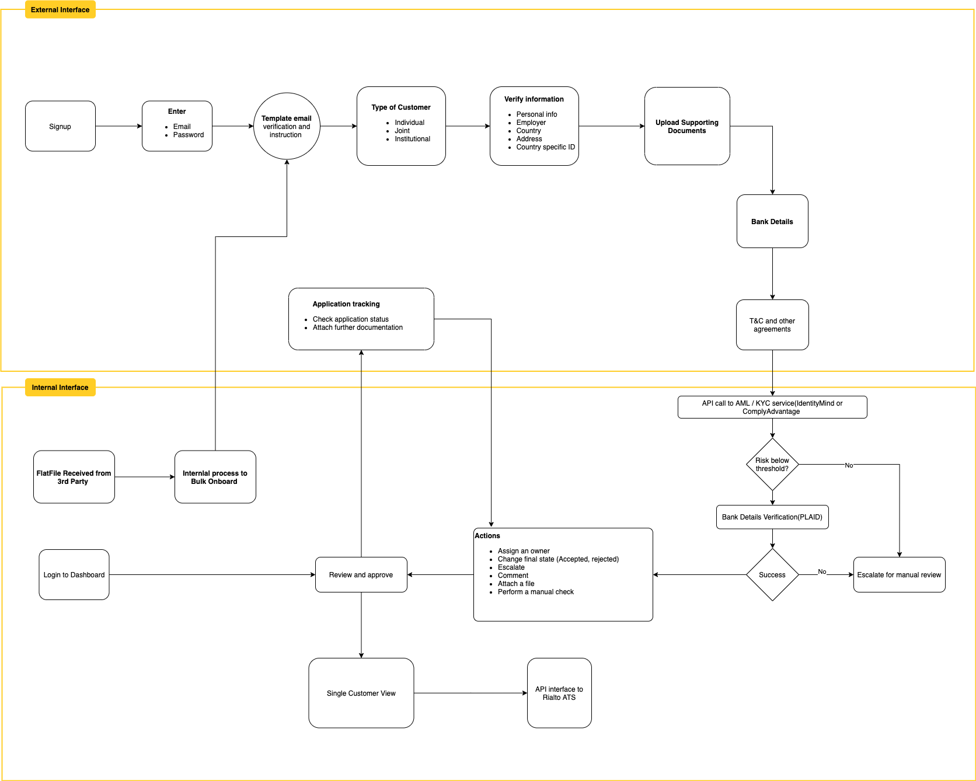

# Retail Investor Interface

This web-based onboarding interface allows investors to apply to trade on Rialto Markets ATS. The investor uses structured forms provided by the onboarding interface to input information securely into the system, attach supporting documents, and track application progress. The provided by the investor allows Rialto Markets to make a decision whether to onboard the investor to the ATS.

## Self Registration with Email

Users can register with email and receive an email verification link to set up a password and begin filling out the application.

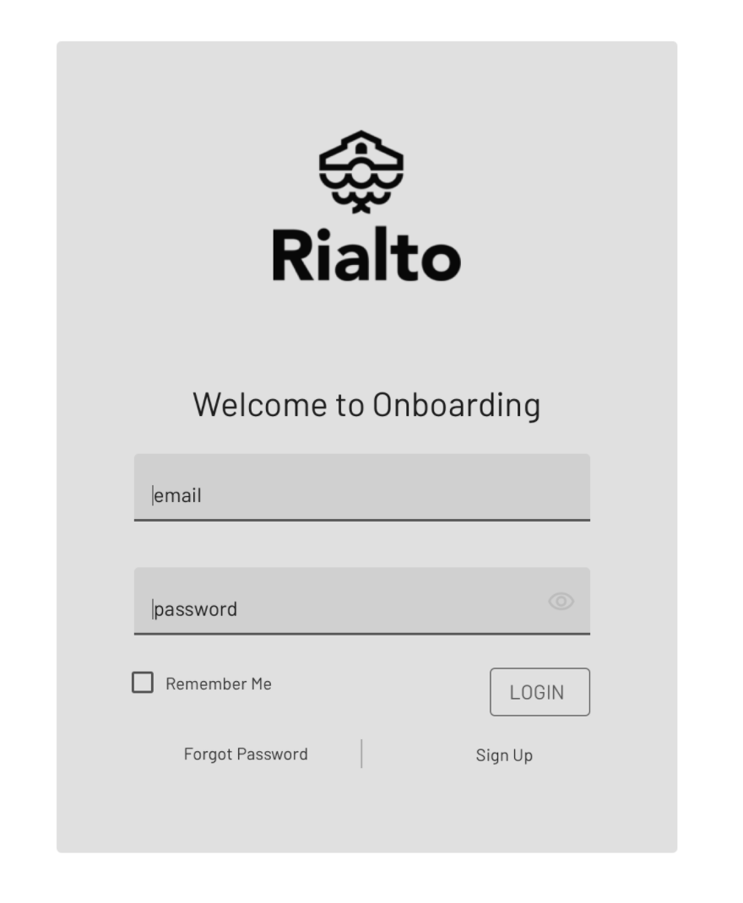

### Email Verification and Password Setup

The user received an email with a secure token link. The user clicks the link in the email to verify the email address.  
After the password setup, the user will fill out a set of forms to provide data required for the Retail Onboarding account setup. This information is required by Rialto Markets to perform risk checks on the user through third-party API calls and manual review.

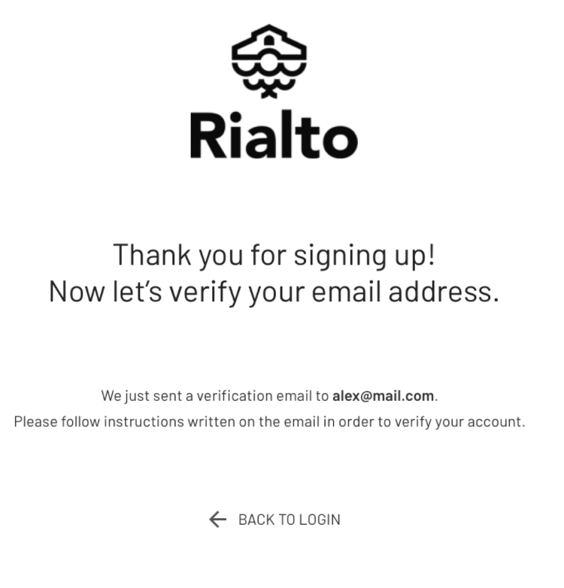

TODO:   
(1) Provide the logo in SVG format and any primary color to show on the login screen.   
(2) Privacy T&C for the user to read through.

I will find / send over logo.

## Applicant Information

### 

### Account Type

The following account types are supported. (Question: how differently should the information be gathered at this stage. Should we just keep it as a flag?)

* Personal
* Joint - not part of phase 1
* Corporate - This is institutional flow. Not part of phase 1

### Personal Details

|  |  |
| --- | --- |
| **Column Name** | **Change requires a new application?** |
| * Title | No |
| * First Name | Yes |
| * Middle Name | Yes |
| * Last Name | Yes |
| * Suffix | Yes |
| * Gender | Yes |
| * Date of Birth | Yes |
| * Tax ID / SSN Number | Yes |
| * Street Address 1 | ? |
| * Street Address 2 | ? |
| * Country | Yes |
| * Zip Code | ? |
| * City | ? |
| * State | ? |
| * Phone number | No |
| * Employer | ? |
| * Job Title | ? |
| * Nationality | ? |
| * Salary Range(Optional) | No |
| * Net Worth | ? |
| * Investment Experience (1 - Expert, 2 - Experienced, 3 - Beginner) | ? |

TODO: open question on whether the user should select whether they are an accredited investor?

Yes, the customer should have a text box to self attest whether they believe they are accredited, with a “hover” explanation of the rules - Net Worth, 2 years of salary or FINRA licenses. If yes, we ask to provide evidence.

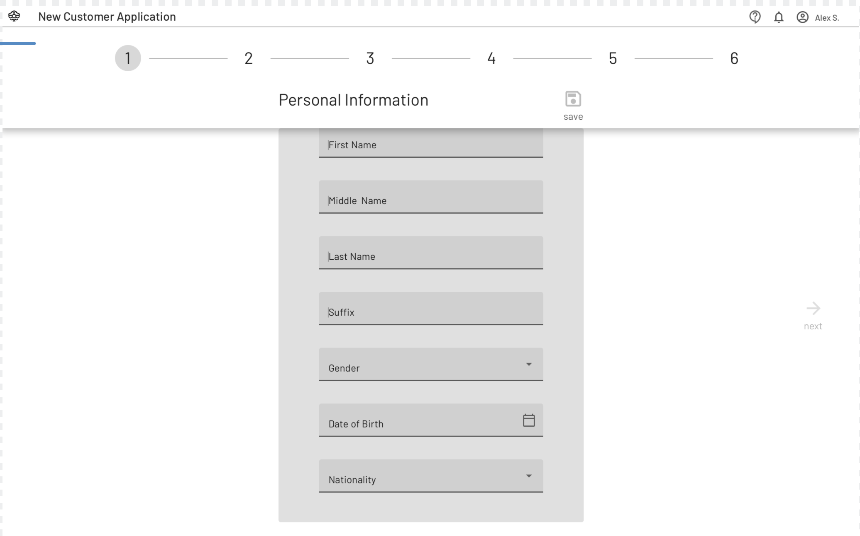

## 

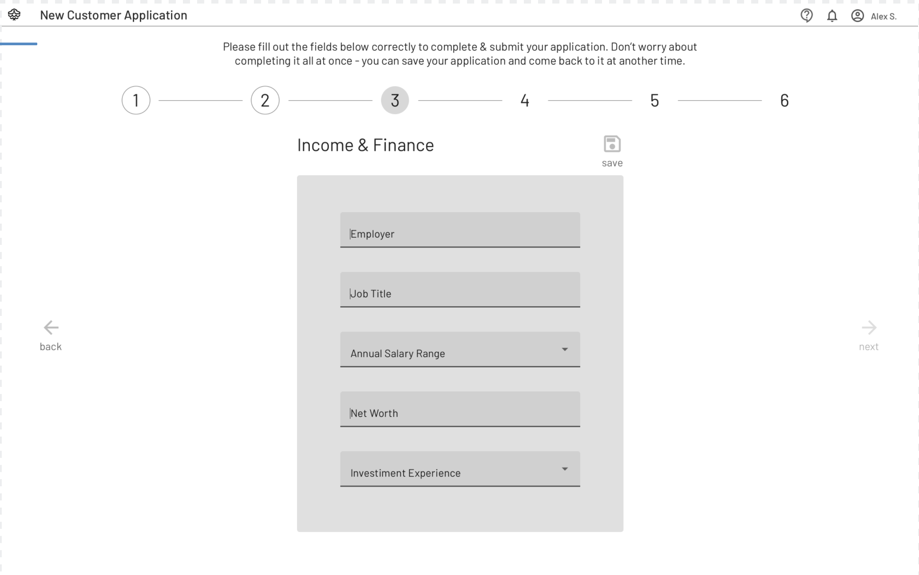

## Documents Upload

User needs to upload the supporting documents for the information provided above

* Country-Specific ID Document
* Address Proof
* Additional Supporting Documents

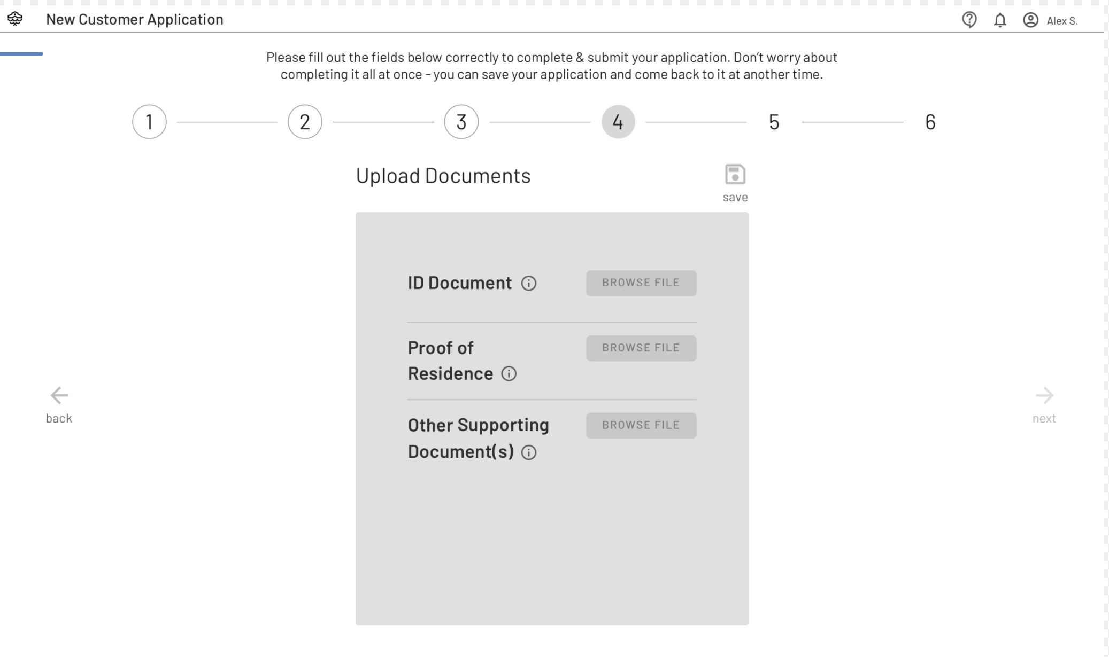

## Transfer Agent

User to consent to sharing information with all the transfer agents that Rialto is connecting to. Following is the consent text to be shown to the user to click through to move forward.

“Rialto is required to query customer positions with all securities transfer agents on our ATS. Do you consent to share your data with the transfer agents in order to be approved?”

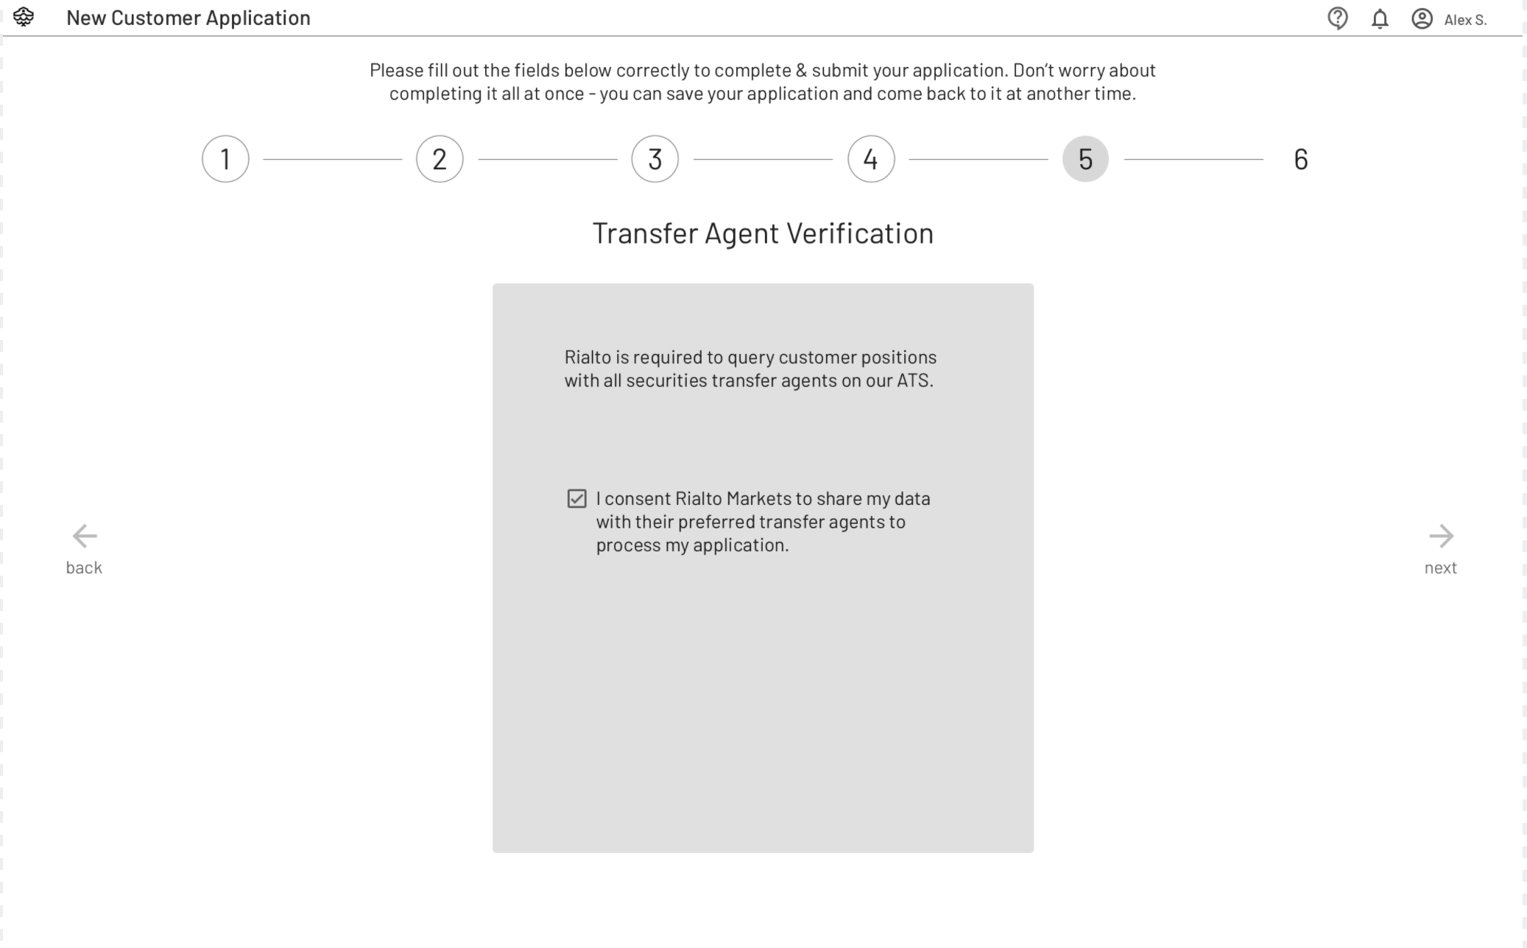

## Funding Source

Two funding options are available for selection.

### Link Bank Account

Choosing this option will take the user through the Plaid integration step for the applicant bank account. This is the default option.

User selects a bank account and is shown the selected bank’s online banking login screen.

Once the user enters the online banking user and password, the user is directed to select a method to confirm a code via SMS or phone.

A code is sent to the phone via SMS.

Once the code is entered into the application, the user account is shown with the account balance.

Choosing this option will take the user through the Plaid integration step for the applicant bank account.

User selects a bank account and is shown the selected bank’s online banking login screen.

Once the user enters the online banking user and password, the user is directed to select a method to confirm a code via SMS or phone.

A code is sent to the phone via SMS.

Once the code is entered into the application, the user account is shown with the account balance.

Video with screen flow: <https://plaid.com/assets/video/how-it-works.webm>

### Open Account With Rialto

Choosing this option will let Rialto know about the user's wish to open an account with Rialto. A separate follow up with the user will be conducted for details needed to open an account. The workflow to open the account will be outside the scope of this application.

TODO: Is there specific language you wish to use for asking the user to open an account?  
Any consent needed for this? We should review the Plaid wire frames provided.

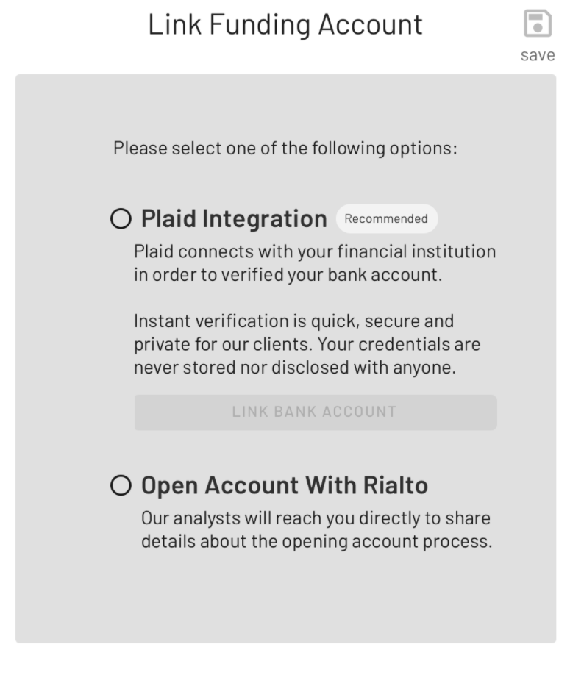

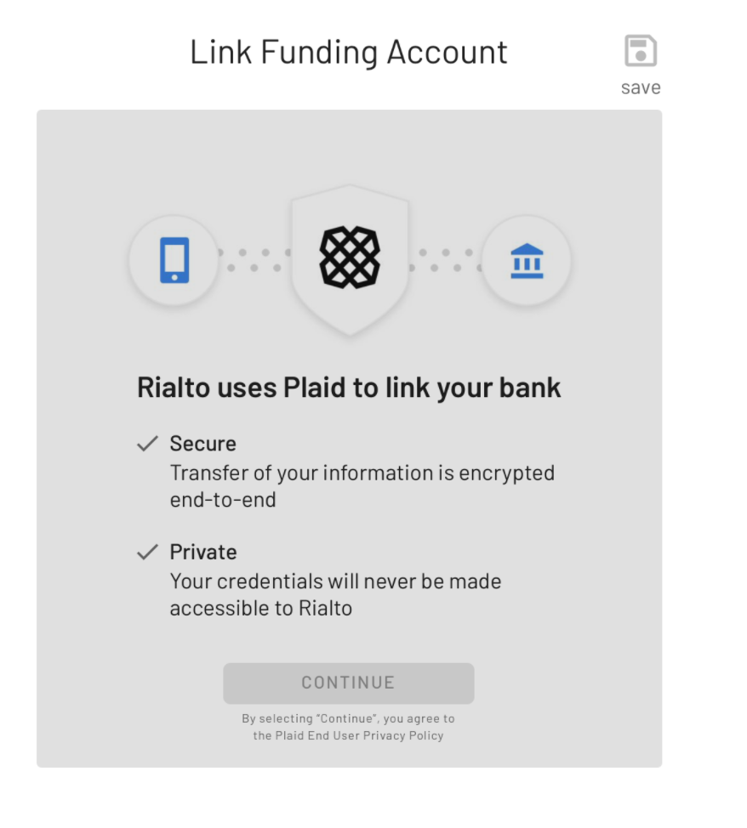

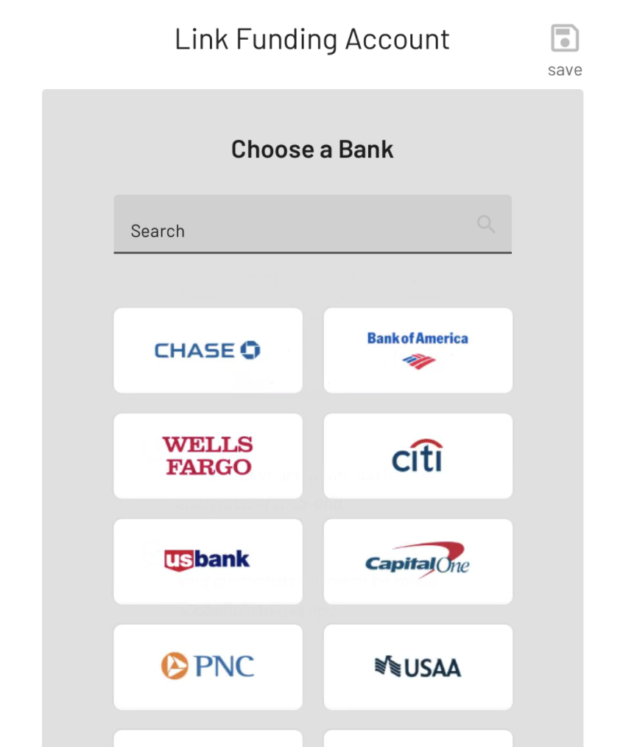

## Application Status

Once the application is submitted, the applicant will be able to view the status of the application by logging into the interface. Additionally, the application will be able to see the details of the application until the application is finished(rejected or approved).

If the application changes the status to “Pending Documentation”, the applicant will be able to upload documents to the application. No other details will be allowed to be changed in the current application.

Following status changes are supported for the external part of the onboarding application interface:

**Draft** - Application is not finished and submitted by the applicant.

**Submitted** - Application is finished and submitted

**Under Review** - Compliance has looked at the application and changed the status to In Progress.

**Pending Documentation** - Additional documentation requested by Rialto Compliance

**Rejected** - Rialto compliance rejected the application

**Approved** - Rialto Compliance has approved the application

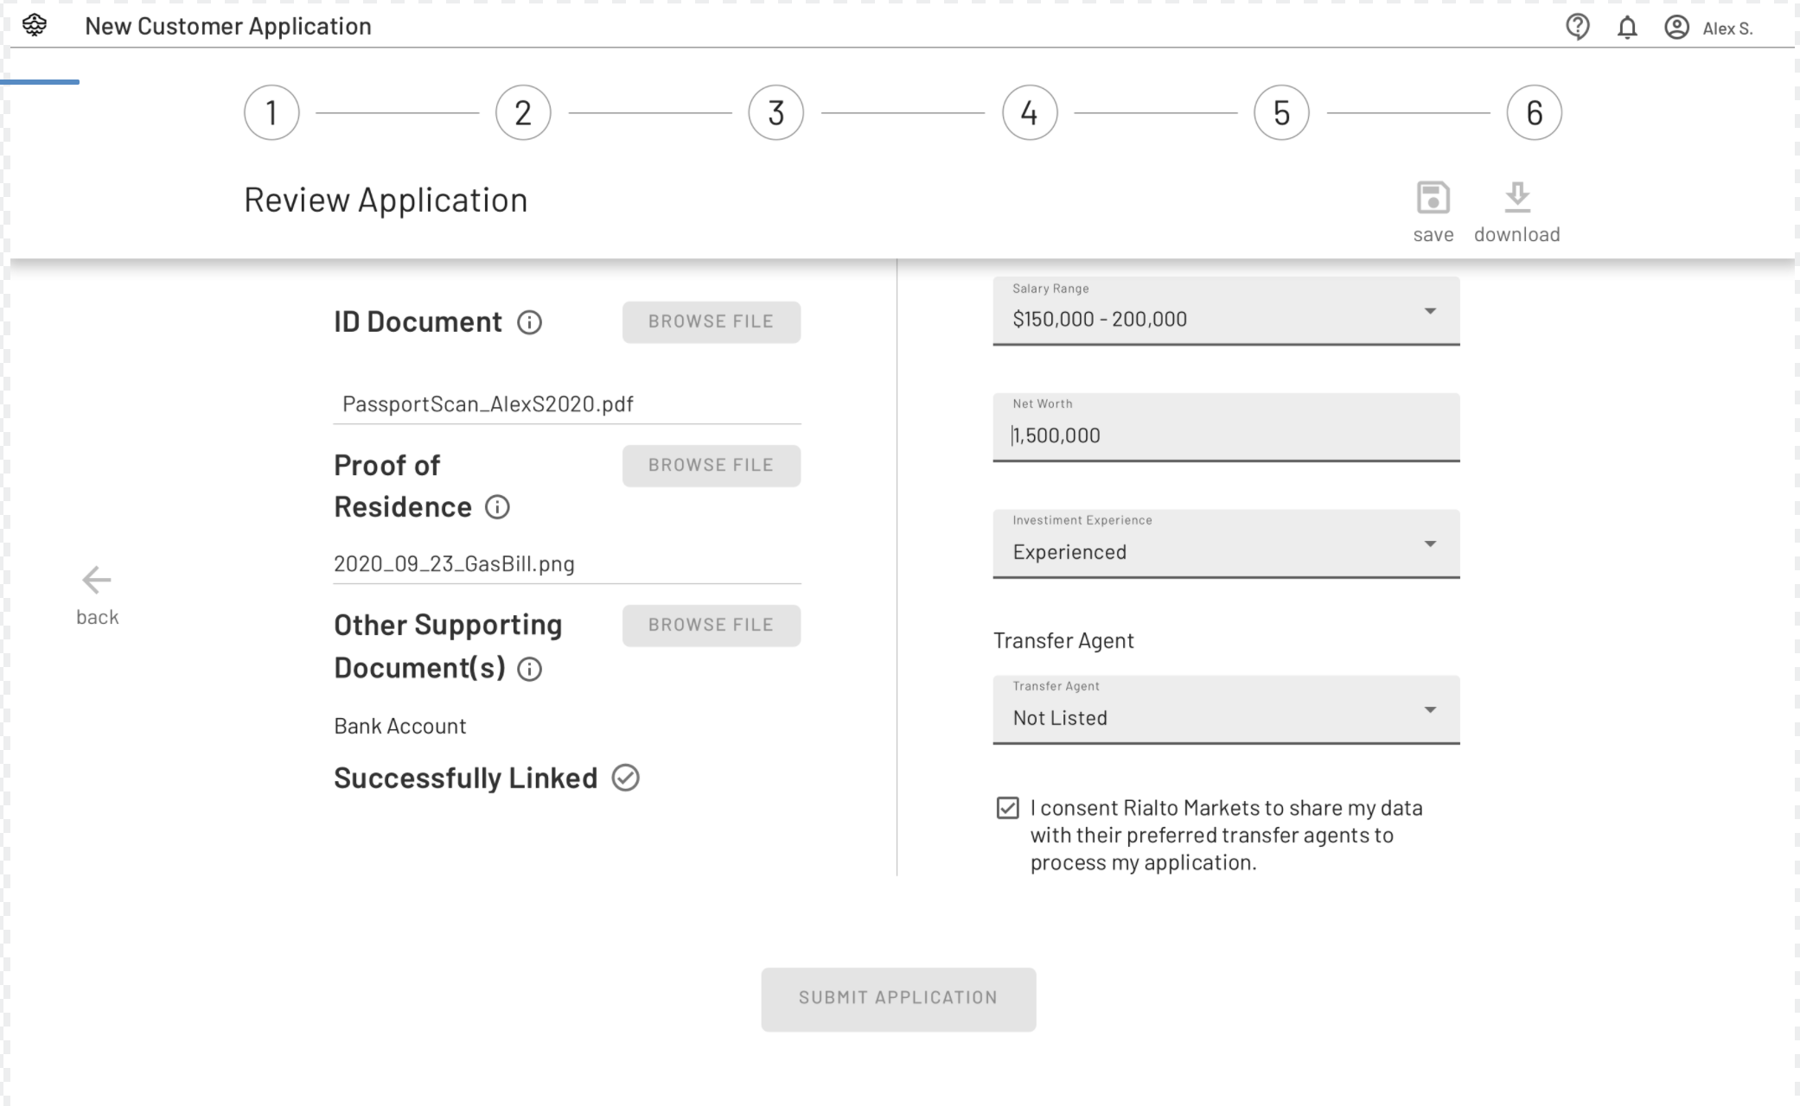

### Updates and communication

Any status updates on the application will show up on the UI at the top bar. Status updates will also generate an email notifying the user of a change in status on the application.

In addition to the status updates visible to the user on the UI, the user will be able to add comments to the application which will flow to the compliance analyst on the Tardis dashboard.

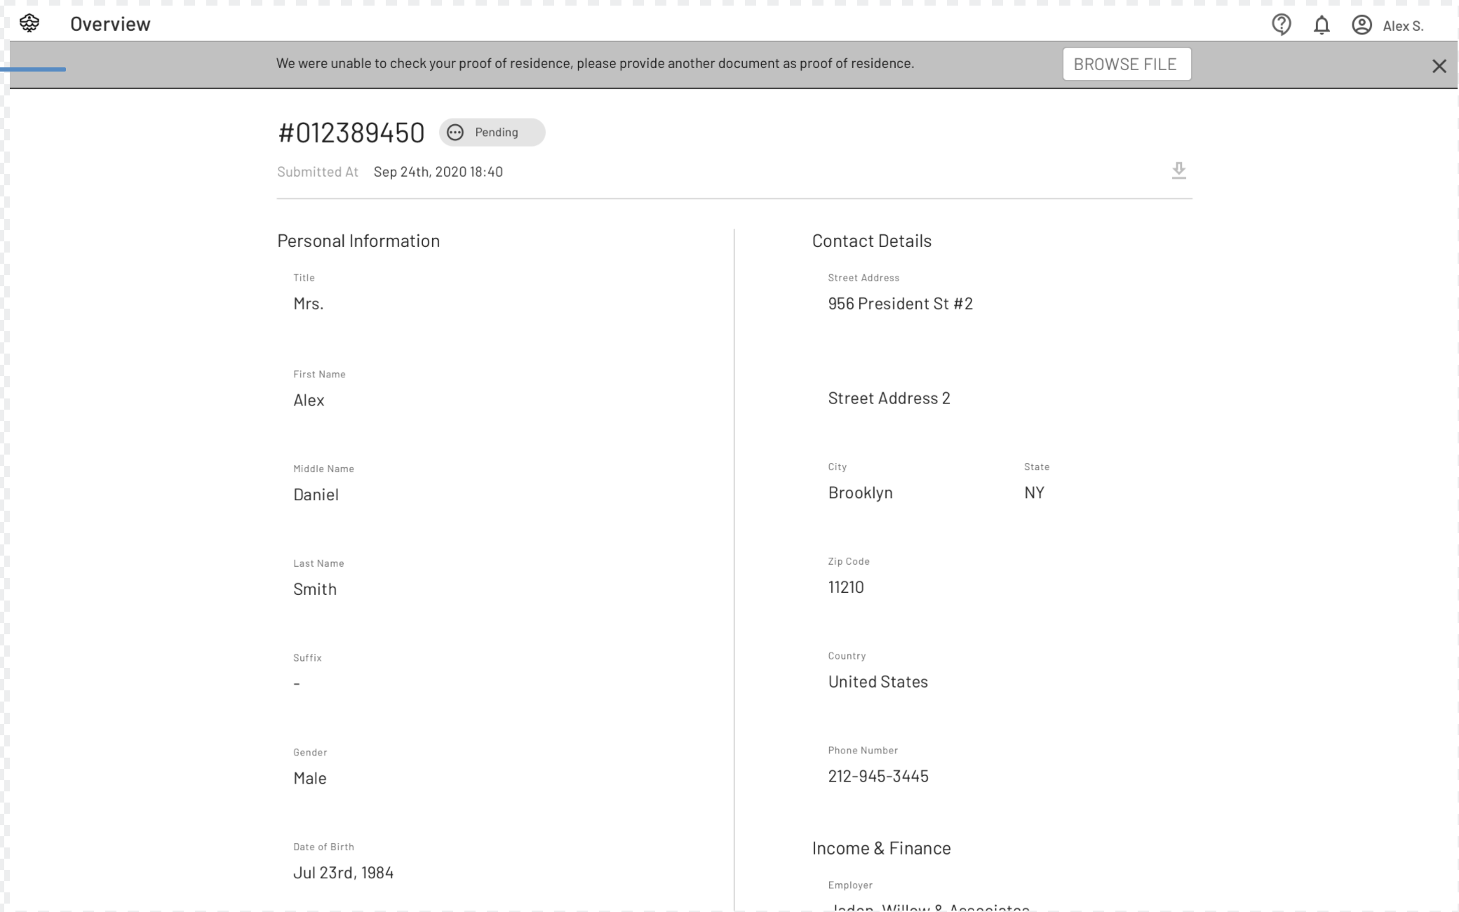

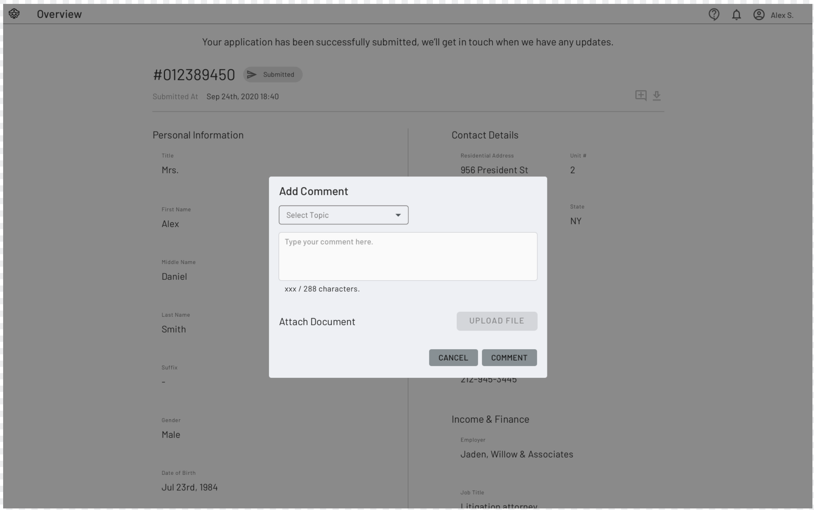

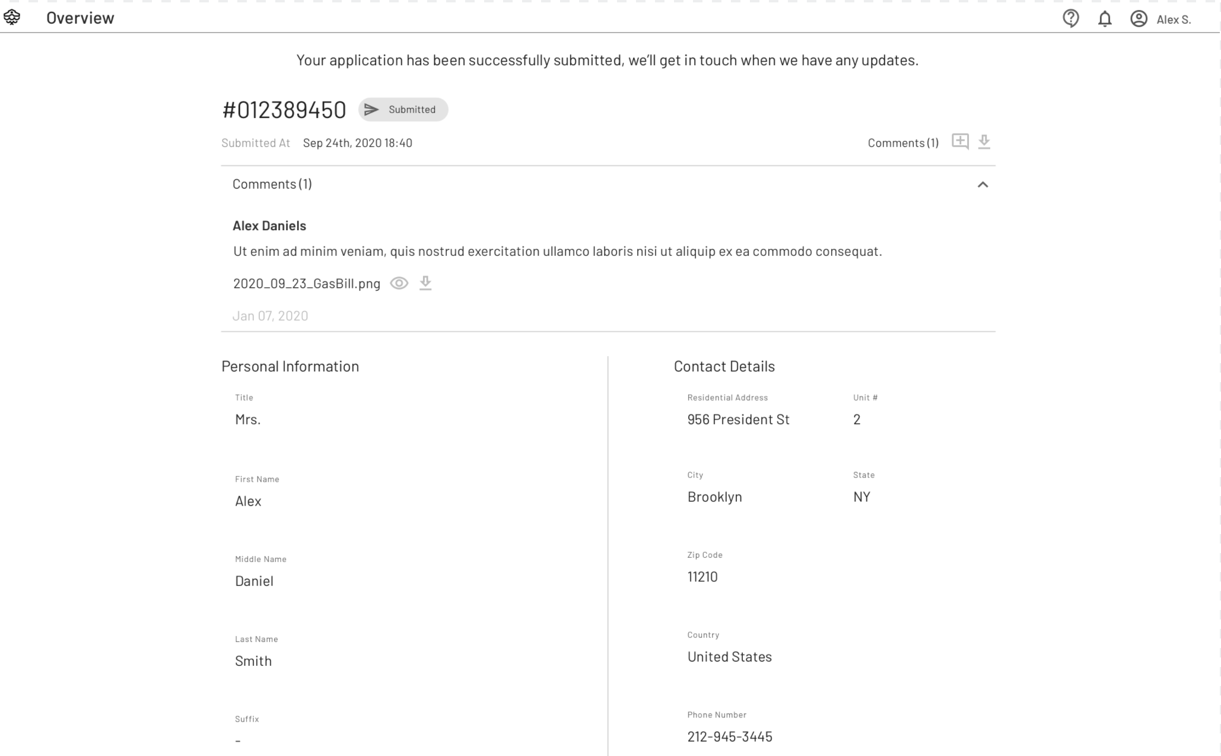

# Compliance Interface

Rialto Markets compliance users can log in to the Solidus Dashboard to check the status of pending applications, review results of the third-party checks, and approve or reject the applications.

### Applications Overview

This section shows the stats on the application in the system across different workflow statuses as well as trends across the past week.

### Application Queue

Application queue shows the list of applications across different statuses. Allows grouping and sorting of applications across different columns. Users can drill down into each application in the list from this screen.

### Application Details

Application details show all the information provided by the applicant including attachments for review, the result of the third-party checks which have already run on the application. Compliance users can review and take action on the application according to the current status.

### AML/KYC Checks Integration

The result and status of each check will show on the application details section. Compliance users can review the result and override the check if necessary.

The following checks are to be performed through IdentityMind Integration in the following order. Any check failure will pause further checks until a manual review and override by the compliance user.

* FinCEN check
* Adverse media
* ID Document Verification

### Single Customer View

Single Customer View(SCV) provides a single source of truth for a client onboarded on Rialto Trading ATS. Client records are kept in sync with the ATS using custom integration as defined in the following section.

### ATS Integration

**New Account Onboarded** - Signal to the ATS/Account interface upon successful onboarding

**Account Actively Trading** - Signal from ATS/Account upon status change to active trading

**Trading Activity Analytics** - Trading activity update from ATS to update Single Customer View

**Account Suspension from SCV** - Signal from Single Customer View to suspend account

**Account Suspension from ATS** - Status update from ATS into Single Customer View

### Bulk Onboarding

There will be a process to upload a set of user data to initiate the onboarding application process. Open questions remain on:

* What specific information will be provided as part of the bulk update?
* Will users have to upload documents as part of this process?

Rialto to provide the following:

* T&C for the applicant
* Branding
* Banner and Copy